Name: _____________________________________

Reaction Time Assessment

1. Write a hypothesis for your experiment.

(1 mark)

2. Identify the independent and dependant variables in this investigation

(2 marks)

3. Identify THREE extraneous (uncontrolled) variables, or any other sources of error in this experiment.

(3 marks)

4. Do you think your hypothesis was supported with the data collected? Why/Why not?

(1mark)

5. Has the data been affected by the “practise effect”?
What do you think the practise effect is?

(1 mark)

To find out, plot your data for three members of your group for their 5 trials for the “Before” or “Normal” situation on the grid below (Hint. Trial number is on the horizontal axis) Now answer the question above in the lined space below the graph. Include supporting evidence from your graph.
(4 marks)

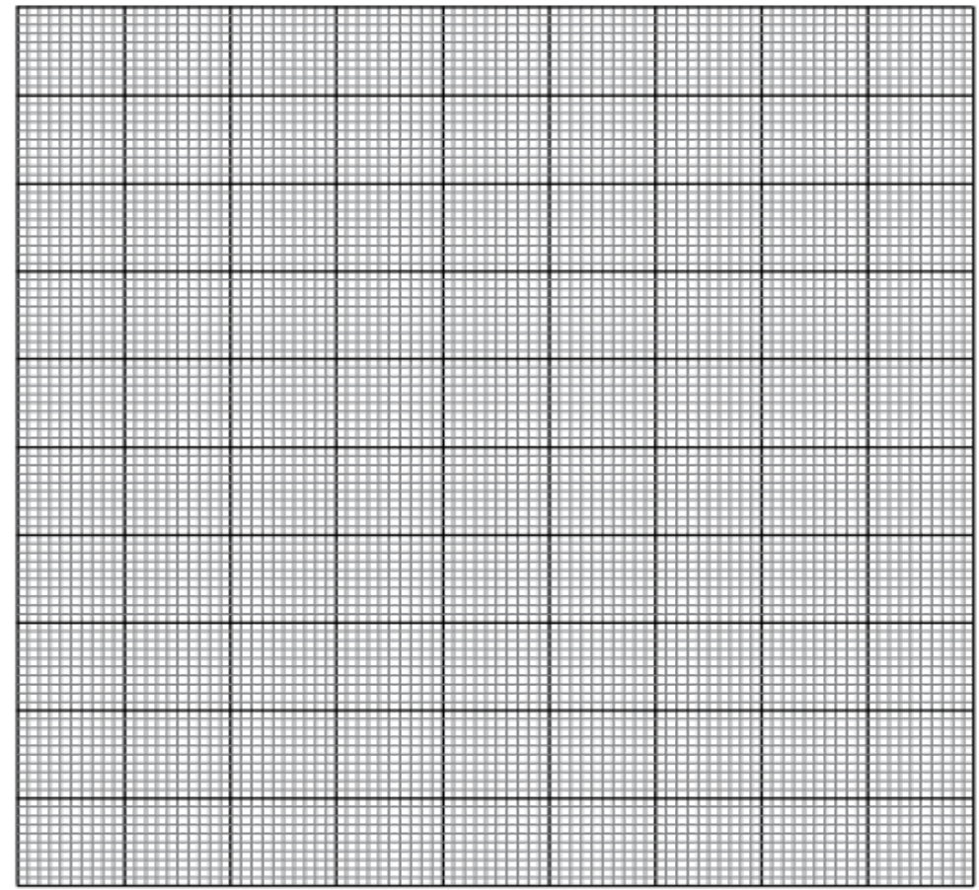

(2 marks)

6. What part of the brain would be involved in the practise effect?

__________________________________________________________________ (1 mark)

7. If the practise effect did exist, what effect might this have on your overall results and thus your conclusion?

(1 mark)

8. Comment on the validity and reliability of your investigation.

9. Draw a flow chart of events that result in the button being pushed. Include the relevant parts of the brain and spinal cord, and the neurons involved. DO NOT go into detail
about action potentials or neurotransmitters. The starting point has been provided for you.
(4 marks)

Visual stimulus of the light going red reaches the eyes

